Mid-Week Update for the week of
December 28 to January 3, 2021
Published December 30, 2020

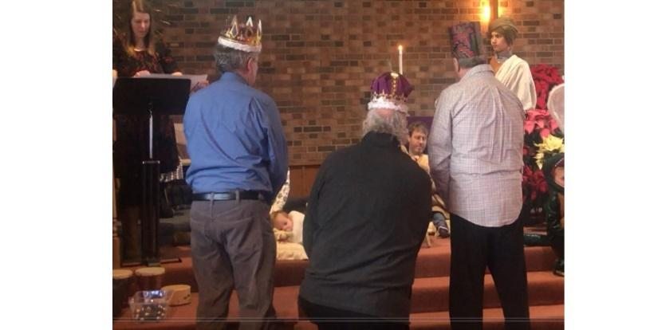

From the Pastor
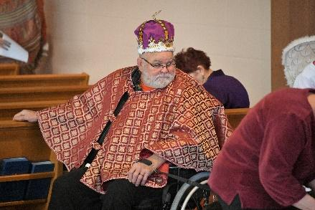
Epiphany -- the church holiday when we commemorate the arrival of the Wise Men from the East to honor the Christ child -- can be silly, like the great scene in Monty Python’s Life of Brian when the wise men arrive at the wrong house. We think of kids in cardboard crowns
(or my personal favorite, my husband
Frank with crown and cape last year).
But the story behind the cardboard crowns is not silly. It’s grizzly. The visit of these Big Shots from the East introduces the threat of violence and murder. They’d stopped in to see murderous King Herod to get directions to where the star was leading them, and their arrival tipped Herod off that there was something big going on in Bethlehem. It is good that the Wise Men brought with them expensive gifts, as it is likely that Mary and Joseph sold those gifts to finance their escape to Egypt as political refugees. They were avoiding murderous King Herod who had ordered all babies to be killed in order to get rid of a potential political rival.
In our Zoom bible studies I am struck by how often a participant starts out a comment by saying, “I hate to get political, but. . .” There is no reason to apologize for getting political. King Herod’s murderous campaign was political. Mary and Joseph escaping with their baby boy to Egypt was political. The Minnesota Council of Churches advocating for the United States to begin again to accept an appropriate number of refugees for resettlement is political. Christian, Jewish and Muslim religious leaders (through the Joint Religious Legislative Coalition of which we are members through the Presbytery of the Twin Cities Area) encouraging the Minnesota legislature to pass a bonding bill with $116 million which for construction of affordable housing is political -- but very much a part of our faith.
My number one New Year’s resolution in my role as your pastor is to be MORE political in 2021. Not in a partisan, name-calling way, but in a serious, involved sort of way. Working with our denomination’s political advocacy center in D.C. (the Presbyterian Washington Office) and the Joint Religious Legislative Coalition here in Minnesota, every month I am going to take one concrete political action to advocate for the poor, homeless, and other people in need -- and I will invite you to join me to do the same.
Happy New Year, everybody. 2020 will be gone soon (thank goodness). 2021 is
going to be better. Let us thank God that we’ve made it this far -- and commit ourselves to keep on keeping on.
Pastor Heidi

Mission Weekly Update /
Peace Offering
Thank you to everyone who contributed to the Christmas Joy Offering. We received a total of $1335.00.
The Mission Committee met in December with an agenda to find a place for the $400.00 our church was able to keep from the Peace Offering. We decided on once again giving to The Immigrant Law Center of Minnesota.
During this difficult year immigrants have often been forgotten. The Dreamers have been under scrutiny in the last several years and the following story tells of one of these Dreamers.
When Aung was six months old His family fled the violent civil war of Burma. For thirteen years his family lived in refugee camps. In 2008 Aung and his family came to Minnesota. Coming to Minnesota did not end Aung's difficult life. He lived in an extremely abusive home environment. With no mental health resources in his native language, Aung became involved in drug use. He was taken into ICE custody and faced deportation to Burma where he would likely be tortured.
With the help of The Immigration Law Center and many months of work Aung has secured protection from deportation. Now at the age of 25, Aung has a second chance at life. This is just one story of the people who has been helped by this organization.
Pat Wilson

Events This Week
Thursday, December 31. 10:30 am Zoom Bible Study. We will discuss Matthew’s account of the arrival of the Wise Men in Matthew 2: 1-12.

Session Members
January 17 – Deadline for ALL of your committee reports due at the church office. See last year’s annual report (Session Member’s Portal on the church website) and use it as an example, should you need one.
January 21 - Next Session meeting, where your committee reports will be formally
accepted and the budget approved.
February 7 - Annual Congregational Meeting following service at 12:00 noon.
Terry Kubista

We Three Kings
(A Pandemic Parody)
As we celebrate Epiphany on Sunday, January 3rd, the COVID pandemic brings us a new version of the familiar carol, We Three Kings, with lyrics written by R.G. Huff - "A Serious Hymn-writer Gone Rogue" - and beginning with "We three kings are six feet apart, we'll Purell before we depart."

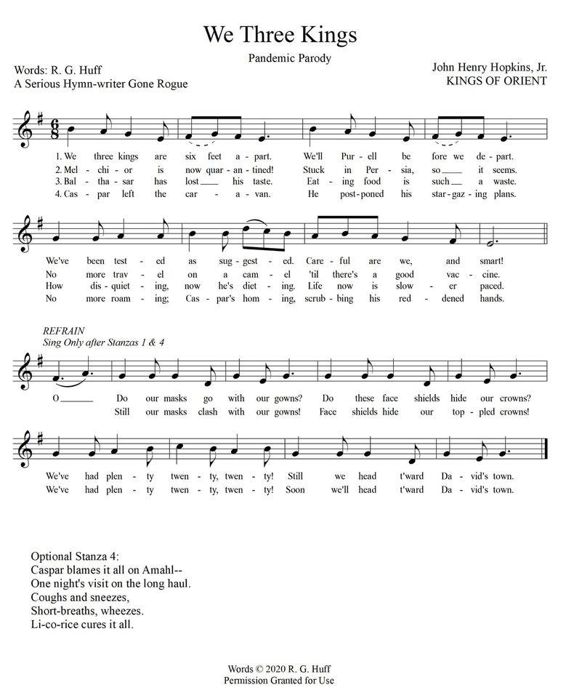

Prayers

A New Year’s Prayer: Take a deep breath and be present every moment of every day of 2021. Love with intention. Be the Church. Practice radical hospitality. Celebrate others. May the grace of God fill your days so that you cannot help but respond to all of life with exuberant joy!
Robin Councilman: On December 26th, our country hit the milestone that one of every 1000 people have died of COVID-19. Pray for all the families who are missing a member this holiday season. Also, pray for an equitable rollout of these vaccines and for production and distribution problems to be quickly overcome.
Marcia Curley asks for prayers for Hopkins Schools and other districts who will be rolling out and having students come back full-time. Mid-January K-2 will start and then grades 3-6 will begin a week later. It is a lot of change ahead for the kids, staff and families.
Bob Unze asks for prayers for his friend Curt Stull whose wife, Marybeth, is at HCMC due to strokes. She has been removed from life support. Please pray for Curt and his daughter Amy.
Anjel Starr has safely arrived in Minnesota and is doing well (Grandmother Lynne says that was the best Christmas present!) and was in worship with us on Sunday. Welcome Anjel!
Joan Amara Green and Elizabeth Green are currently in Liberia visiting family, friends, and delivering school supplies to needy children. Elizabeth is also doing some research about possible ways for our church to help children in Liberia.
Karen Mayer and Mark Maier are recovering from COVID and doing well. Prayers of thanksgiving!
We pray for those who are the most vulnerable: those who are sick, people in jails and prisons who are exposed to the Covid-19 virus at alarming rates, the frail elderly, and all those who care for them.
If you have any prayer requests that you would like printed in the Mid-Week Update, please e-mail them to peaceprezslp@gmail.com or call the church office at 952-545-2586 and leave a message.

Worship Resources
Click on this link for all Church events:
https://zoom.us/j/5046768135

You can also open the Zoom app and entering the meeting ID 504-676-8135.
To dial in, call 312-626-6799 (long-distance).
The meeting ID is 504-676-8135.

To watch previous worship recordings on our YouTube channel, go to
www.youtube.com/channel/UCvOa5jl8xld1VtI105h6ZRA/. They are also on our website at https://www.peaceprez.com/worship-recordings/. We will continue to post Sunday bulletins ahead of the service on our website at https://www.peaceprez.com/news/publications/

Calendar
This Week:

Thursday, December 31
10:30 am – Bible Study, on Zoom

Friday, January 1, 2021
Happy New Year!

Sunday, January 3 - Epiphany
10:30 am –Worship service, live on Zoom and Facebook.

Next Week:
Tuesday, January 5
10:30 am – Morning conversation and prayer, on Zoom

Thursday, January 7
10:30 am – Bible Study, on Zoom

Sunday, January 10 – Baptist of our Lord
10:30 am –Worship service, live on Zoom and Facebook.

Upcoming Birthdays
David Councilman Dec. 31
Eileen Unze Jan. 3
Marty Landsem Jan. 6
Charles Koehler Jan. 11
Janet Armajani Jan. 12
Eunice Goodrich Jan. 14
Alex Staib Jan. 15

If You Have Information that needs to be in the weekly update such as meeting dates and times, special events or prayer requests, please get this information to our office manager Patrice by Wednesday morning. Please email or call peaceprezSLP@gmail.com or 952-545-2586.

