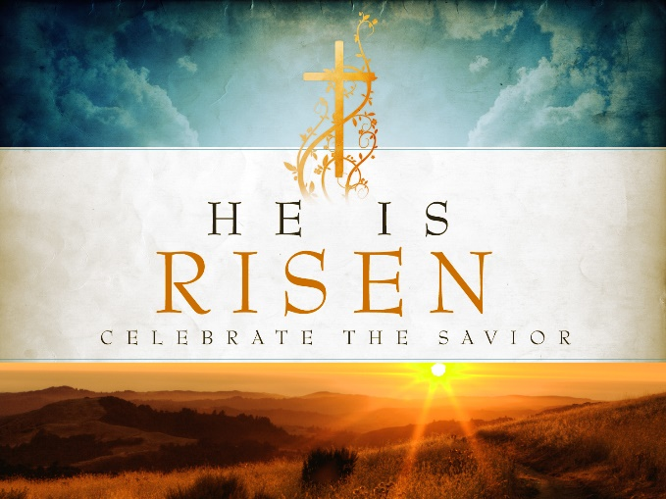

April 11, 2021, 10:30 am

As we prepare for worship, please send your prayer requests by way of the “chat” function on Zoom or send a message through Facebook.

Order of Worship

Prelude Musician Patrice Meschke

Welcome Pastor Heidi Vardeman

Gathering Song #123, verse 1 Jesus Christ is Risen Today
Jesus Christ is risen today, Alleluia!
Our triumphant holy day, Alleluia!
Who did once upon the cross Alleluia!
Suffer to redeem our loss. Alleluia!

Call to Worship
Give thanks to the Lord, for God is good. God’s mercy endures forever.
Let the redeemed of the Lord proclaim that it is God who saves us from the hand of the foe.
Troubles, we cry to the Lord who saves us from every distress.
Let us give thanks for the mercy of God, and for all the wonders of the Lord.

Hymn #122, verse 1 Thine is the Glory
Thine is the glory, Risen conquering Son
Endless is the victory, Thou o'er death hast won
Angels in bright raiment, Rolled the stone away
Kept the folded grave clothes, Where Thy body lay
Thine is the glory, Risen conquering Son
Endless is the victory, Thou o'er death hast won

Confession of Sin
Almighty God, in Jesus Christ you called us to be a servant people, but we do not always do what you command. We fall silent when we should speak, and useless when we should be useful. Too often we are lazy and timid. Forgive us. Amen.

Sung Response (unison)
You are the Lord, the Author of mercy
You are the Christ, the Pattern of mercy
You are the Lord, who holds us in mercy

Declaration of Forgiveness
… Friends, believe the good news of the Gospel;
In Jesus Christ we are forgiven. Alleluia and amen!

Song of Rejoicing Up from the Grave He Arose!
Up from the grave he arose,
with a mighty triumph o'er his foes;
He arose a victor from the dark domain,
and He lives forever, with His saints to reign.
He arose! He arose! Hallelujah! Christ arose!

Passing the Peace
… The peace of Christ be with you.
And also with you.
Participants can now “unmute” themselves. Add video if you are on Zoom. Please greet one another by waving, smiling, or saying “Peace!”

Concerns of The Church

Special Music

Scripture Reading John 20: 19-31
When it was evening on that day, the first day of the week, and the doors of the house where the disciples had met were locked for fear of the Jews, Jesus came and stood among them and said, “Peace be with you.” After he said this, he showed them his hands and his side. Then the disciples rejoiced when they saw the Lord. Jesus said to them again, “Peace be with you. As the Father has sent me, so I send you.” When he had said this, he breathed on them and said to them, “Receive the Holy Spirit. If you forgive the sins of any, they are forgiven them; if you retain the sins of any, they are retained.” But Thomas (who was called the Twin), one of the twelve, was not with them when Jesus came. So the other disciples told him, “We have seen the Lord.” But he said to them, “Unless I see the mark of the nails in his hands, and put my finger in the mark of the nails and my hand in his side, I will not believe.”

A week later his disciples were again in the house, and Thomas was with them. Although the doors were shut, Jesus came and stood among them and said, “Peace be with you.” Then he said to Thomas, “Put your finger here and see my hands. Reach out your hand and put it in my side. Do not doubt but believe.” Thomas answered him, “My Lord and my God!” Jesus said to him, “Have you believed because you have seen me? Blessed are those who have not seen and yet have come to believe.” Now Jesus did many other signs in the presence of his disciples, which are not written in this book. But these are written so that you may come to believe that Jesus is the Messiah, the Son of God, and that through believing you may have life in his name.

Sermon

Hymn #122, verse 2 Thine is the Glory
Lo! Jesus meets us, Risen from the tomb
Lovingly, He greets us, Scatters fear and gloom
Let the church with gladness, Hymns of triumph sing
For her Lord now liveth, Death hath lost its sting
Thine is the glory, Risen conquering Son
Endless is the victory, Thou o'er death hast won

Sharing Our Joys and Concerns
If you are on Zoom and able to “chat” you can share your prayer concern by clicking “everyone” or you can send a private message to Peace Presbyterian. If you are watching on Facebook, you can write your prayer as a comment on the livestream.

Prayers of the People

The Lord’s Prayer
Our Father in heaven, hallowed be your name,
Your kingdom come, your will be done,
On earth as it is in heaven.
Give us today our daily bread.
Forgive us our sins as we forgive those who sin against us.
Save us from the time of trial and deliver us from evil.
For the kingdom, the power, and the glory are yours now and forever. Amen.

Offertory

Doxology #591
Praise God from whom all blessings flow
Praise Christ all people here below
Praise Holy Spirit evermore
Praise Triune God whom we adore. Amen.

Prayer of Dedication

Hymn #122, verse 3 Thine is the Glory
No more we doubt Thee, Glorious Prince of life
Life is naught without Thee, Aid us in our strife
Make us more than conquerors, Through Thy deathless love
Bring us safe through Jordan, To Thy home above
Thine is the glory, Risen conquering Son
Endless is the victory, Thou o'er death hast won.

Benediction

Fellowship

Join us after the Zoom worship service for fellowship!

