7

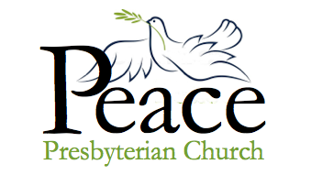

Midweek Update for the week of
October 10 – October 16, 2021
Published October 13, 2021

Join us for the Church Retreat!

The Peace Church retreat is Saturday, October 23rd from 9:00 am to 5:00 pm at the YMCA Camp St. Croix located in nearby Hudson, Wisconsin.

From the Pastor

My computer is in the shop until tomorrow, so I will be brief. I am very excited about the all-church retreat on October 23! A planning committee has already done some great work. We’ll be talking about the new things that God helps us to deal with. Come ready to share what the pandemic shutdown was like for you. Now that we hope we can see a light at the end of the tunnel, we can begin to put together a “new normal” which will be new, but it will be different.

There will be crafts for the crafty (sock puppets!) and time to walk – or just sit – to enjoy the beautiful grounds of Camp St. Croix in Hudson, WI. There will be carpools!! Info about the carpools will be announced on Sunday and mailed out in next week’s Mid-Week Update.

There is a suggested donation of $10 per person, but no payment is required. You are welcome to bring friends and family – but make sure to let the office know how many are coming so we’ll get enough carpool drivers and food!

Faithfully yours, Pastor Heidi

Upcoming Zoom and
In-Person Meetings

This Week

Wednesday, October 13
7:00 am – Wednesday Get-Together Meeting, via Zoom. Program TBD.
https://us02web.zoom.us/j/5046768135
Meeting ID: 504 676 8135

Thursday, October 14
10:30 am – Bible Study, on Zoom. Heidi will lead the discussion on Mark 10: 43-45.
Sunday, October 17 – Worship
9:00 am – Worship service via Zoom
10:30 am – In-Person Worship. Liturgist, Michele Gallick.

Next Week

Tuesday, October 19
10:30 am – Morning conversation and prayer, on Zoom. Everyone welcome!!

Wednesday, October 20
7:00 am – Wednesday Get-Together Meeting, via Zoom. Program TBD.

Thursday, October 21
10:30 am – Bible Study, on Zoom.
7:00 pm – Session Meeting, on Zoom.

Saturday, October 23
9:00 am – 5:00 pm – All-Church Retreat at YMCA Camp St. Croix, Hudson, WI.

Sunday, October 24
9:00 am – Worship service via Zoom
10:30 am – In-Person Worship. Liturgist, Ron Abrahamson.

If You Have Information that needs to be in the weekly update such as meeting dates and times, special events or prayer requests, please get this information to our office manager Patrice by Wednesday morning. Please email or call peaceprezSLP@gmail.com or 952-545-2586.

Just a reminder that Tuesday, Nov 2, is the General Election, with polls open 7am to 8 pm. Minnesota has yearly elections so we do not forget. This year we are voting for SLP City offices (ward council members) and school district offices. (Thanks for the reminder, Brenda!)

A Virtual Tour of Vietnam

This week, Tom and Eunice learn the fine (and scary) art of crossing a Hanoi street!
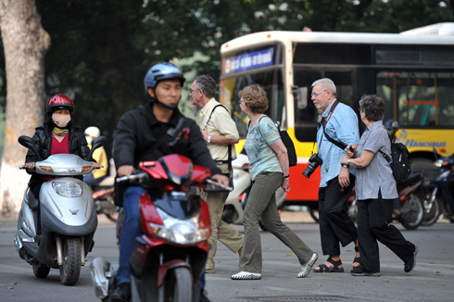

I’ve mentioned all those motor bikes, sometimes four lanes at a time all speeding by; however, stop signs and lights were not at all corners. You had to learn to watch for a slight break in the traffic, and I do mean small. Immediately you started to walk into the street, and those bikes were still coming but somehow as if a guardian angel were with you, they parted the road around you and you somehow made it to the other side.

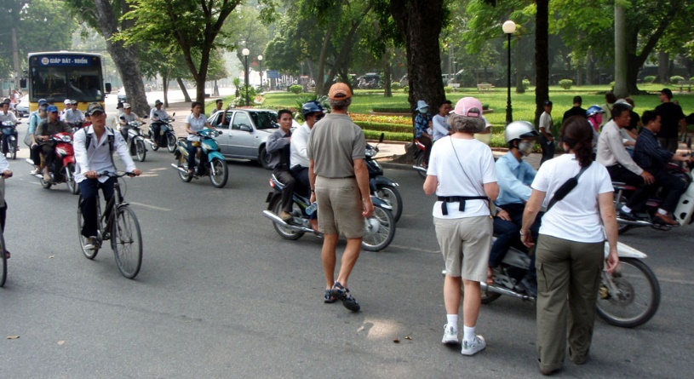We were instructed to never stop in the middle of the street and not to speed up, but keep the same walking pace at all times, for as our guide Tom said, “you will mix them up if they do not know what you are going to do. It is their job to watch you and your job is to keep walking.”

I can tell you one thing truthfully - it was a frightening first walk! However, Tom kept walking in front of us and talking to us calmly all the way. It took a few days before most of us ventured out on our own, each with bated breath, and I was hanging on mighty tightly to my Tom’s hand the first time we did it on our own. As I looked at the faces of our soon-to-be new friends, we were very lucky we were not suffering jet lag.

I know all of our group made it safely to the other side through the entire trip; however once in Ho Ch Minh City, the traffic was faster with many more cars, and one of our group went on their own to a museum and found it impossible to find a break in the traffic. She finally hailed a cab to drive her across the street to the hotel.

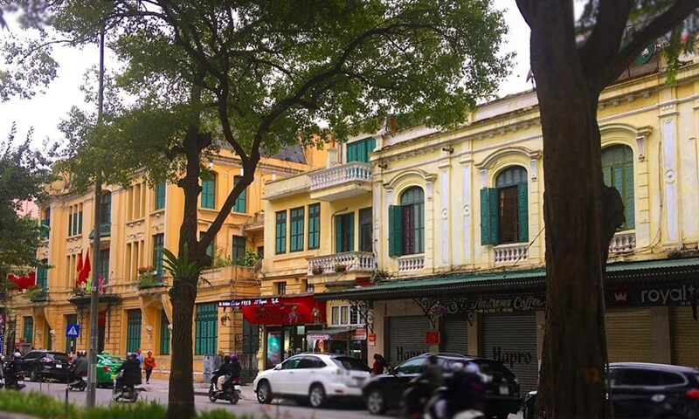
Hanoi is a very beautiful and interesting city. It is so quaint, as it was isolated from the outside world from 1954 when the French departed. It is a combination of Chinese and French style and culture.

The French Quarter has wide boulevards, with gorgeous French charm reflected in the buildings. Trees line the street, and row after row of huge mansions are still in use today. 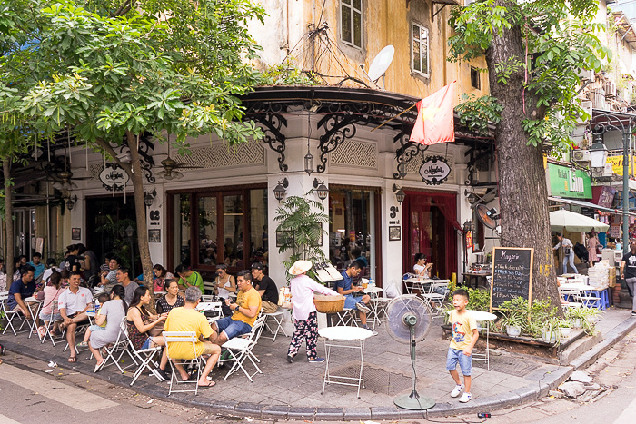There is even a Sofitel, and everywhere in the new and old sections you find lumps of tables scattered out into the street. Coffee is excellent there and the Vietnamese have made taking coffee an art form.

First viewing these tables, one is surprised to find the chairs around them look as if set out for a class of kindergarteners. Yes, most westerners find it a bit difficult at first to maintain their dignity and squat down gently onto one. Getting up, well, let’s just say sometimes it is not pretty…

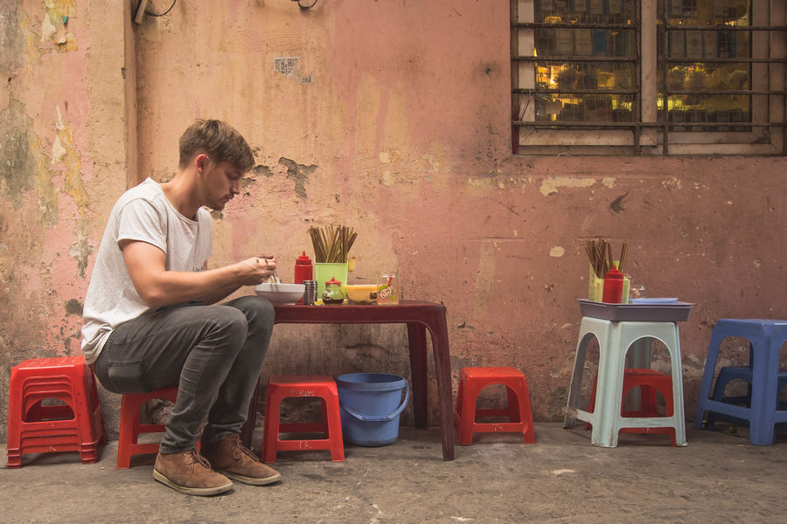These plastic chairs and tables were set up and moved often, for these pop-ups were not licensed businesses. In the early morning hours, the venders rushed to find a spot, and if checked for licenses they just gathered all and left to another spot.

Next week: Exploring the beauty of Hanoi’s lakes.

Nutifafa Returns

Nutifafa is returning to in-person worship! Per an email from Kodjo: “By His grace, I am back from Togo and we (Nutifafa Nyanyui Hame) are ready to resume our church service this Sunday, October the 17th at 1pm as usual. May the Lord continue to be with us.”

Nutifafa is a small worshipping group made up of people from Togo in West Africa. They meet in the church parlor.

All Saints’ Day Remembrance

Peace Church will be observing All Saints Day on Sunday, November 7. All Saint’s Day, also known as All Hallows’ Day or The Feast of the Saints, commemorates all the saints of the church, both known and unknown, and celebrates the powerful spiritual bond between those in Heaven and those on Earth.

We would like to feature your photographs of loved ones so we can lift them up in remembrance and thanksgiving. You can either bring the photos to church and place them on Patrice’s desk in the office (there will be a special basket) or email them to peaceprezslp@gmail.com. The deadline for the photos is Thursday, October 28, 2021.

Joan Hanson, who lives in the Augustana Apartments, has been suffering neck and back pain.

Kent Hall is convalescing at home with pneumonia. Please keep him and Rosemary in your prayers.

Miriam Devery’s daughter, Gail, has a stroke earlier this fall but has been improving. She now lives at Miriam’s house.

Upcoming Birthdays

Dennis Hovdenes October 13
Robin Councilman October 14
Sue Tolchiner October 17
Elizabeth Greene October 18
Jinny Hilf October 21
Jane Helsing October 24
Pat Wilson October 28

Worship Resources

You can click on this link to join the Zoom meeting, for Sunday, Tuesday, Wednesday, and Thursday meetings:
https://zoom.us/j/5046768135
To dial in, call 312-626-6799 (long-distance).
The meeting ID is 504-676-8135.
For Facebook Live: https://www.facebook.com/PeacePresbyterian
To watch previous worship recordings on our YouTube channel, go to
www.youtube.com/channel/UCvOa5jl8xld1VtI105h6ZRA/.
They are also on our website at https://www.peaceprez.com/worship-recordings/.
We will continue posting Sunday bulletins ahead of the service on our website at https://www.peaceprez.com/news/publications/

