117

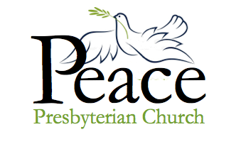

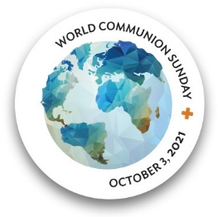
Midweek Update for the week of
September 26 – October 2, 2021
Published September 29, 2021

Join us TONIGHT AT 7PM for a program on Zoom with Dana Councilman!

Dana will be presenting her second session about Liberia, where she served as a Peace Corps volunteer. This one-hour session is a way to prepare us as a church to start doing some work helping with public education of children in Liberia. To join the session, enter Zoom and Pastor Heidi will let you right into the meeting. Come at 6:45 pm and a few of us will be there and we can chat to “catch up” with what’s happening with everybody.

Here’s the regular Zoom link. It is the same address that we use for Sunday morning worship and every other meeting for Peace Presbyterian Church.
Peace & Global Witness Offering

The Peace & Global Witness Offering is this upcoming Sunday - World Communion Sunday, on October 3, 2021.
This offering provides light to those in the shadows and guides us all into the ways of peace. We come together to promote the peace of Christ by addressing systems of injustice in our own communities and around the world.
Twenty-five percent of this Offering stays with local congregations, and 25% with mid councils to unite congregations to support peacemaking in their regions, and 50% is used worldwide.

From the Pastor:

Where have we been? Where are we now? Where are we going?

I’d like to invite everybody at Peace Prez to give some thought to those questions about our church. As our church opens back up and we come back to some sense of normal – though we never know if there will be another surge in the pandemic – we're going to get started on a project to reflect on where we’ve been as a church, where we are now, and where we’re heading in the future.

The idea of this project came from that conference in New York I attended earlier in September. Our teachers encouraged all of us to take advantage of this just-getting-things-together time to encourage our whole congregation to reflect on past, present and future. While things are still quiet at church, how about rooting around in your photograph albums and see if you can find some good pictures of Peace Prez in the past? And while you’re doing that, please consider writing down some memories, too. They could be as recent as last year (for example: what it was like to start attending Zoom worship) and as far back as the church’s very beginnings. If you are not up to writing, please give me a call and maybe we could set up a time for you to talk and I could type things up. My phone is 612.296.7878.

The reason for this? Church life will never be the same after the shutdown caused by the pandemic. Even though it may not feel that way, our own church is doing so much better than so many others. Let’s celebrate where we’ve been and where we are as a way of looking forward to the future. When I came to Peace Prez in 2017. there was a sense that there was no future for PPC, but God has found a way for us. Let’s take some time now to do some reflecting so that, this winter, we can start doing some planning for the future for PPC. Remember the prophet Isaiah who made this point:
Behold! I am doing a new thing. It springs forth. Do you not perceive it.
I will make a way in the wilderness and rivers in the desert.
Isaiah 43:19

Church life will never be like it was when Peace Prez was founded. That’s the world I grew up in, a time of unprecedented high church attendance. People went to church at a percentage rate higher than ever before and since. Did you know that during the Colonial era only about 10% of the population went to church? What some of us think as “the way things always were” in fact was an exception from the rule! Things will never be like that again, so we are left with the challenge of thinking and praying creatively. What new things are being done by our Lord God? How can we best use our building that was designed for that time in the 1950s but needs to be used for mission and ministry today and tomorrow??

One idea that is being floating is putting together an exhibit about the church’s past that can be posted in our church lobby. That will entail digging around in the church archives, looking at photos, deciding what to put up. Are you interested? We can use the office, right next to the church office that used to house Reclamation Ministries, as our headquarters. A few people can come in and work together in a safe manner. Once some photos and documents are collected, our ever creative office manager Patrice can also put this together as a slide show for us to enjoy before or after worship – or on Zoom!

Please let the office or me know if you are interested. We are looking for people to

- Root around in the archives (the closet near the Cedar Lake front door)
- Decide what should go into the display
- Write down their memories
- Dictate their memories
- Be videotaped telling a story about something about PPC’s past
- Help organize this effort

God has been good to us. Please join me in an effort to tell our story.

Faithfully yours, Pastor Heidi

Upcoming Zoom and In-Person Gatherings
Wednesday, September 29
7:00 pm – Liberia Project meeting, taught by Dana Councilman, via Zoom. One-hour presentation and discussion.

Thursday, September 30
10:30 am – Bible Study, on Zoom. Text: Ephesians 2:14-22.

Sunday, October 3: World communion Sunday. Special Offering will be dedicated both at the 9am Zoom service and at the 10:30 in-person worship service.
9:00 am – Zoom Worship Service
10:30 am – In-Person Worship Service (masked and socially distanced). 10:30am in person worship in the sanctuary: Elizabeth Greene is the liturgist. Pastor Heidi will preach “Breaking Down Dividing Walls of Hostility.” Communion will be celebrated near the end of the service, as we all walk out the front door and are served juice in little Dixie cups and pieces of bread. Val Eng will be our musician.
Tuesday, October 5
10:30 am – Morning conversation and prayer, on Zoom. Everyone welcome!!

Come to the Church retreat October 23, 2021
We will be returning to the YMCA Camp St. Croix located in nearby Hudson, Wisconsin for our retreat. Please join us on Saturday, October 23 from 9:00 am to 5:00 pm to enjoy Christian fellowship and lunch.
Even if you are not absolutely sure you will be attending, please respond to the church office - peaceprezSLP@gmail.com - by Sunday, October 3 so we can get an idea of how many might attend.

Donna Howard, Fellowship Committee

Elevator UPDATE

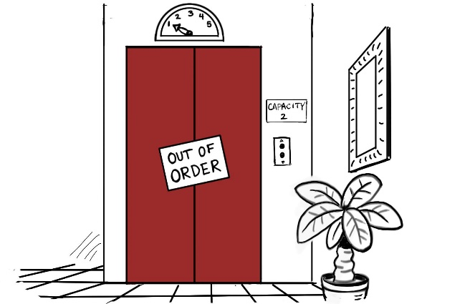

The elevator is being worked on this week, with hopes that it will be fully operational on Sunday! We will keep you updated if this information changes.

A Virtual Tour of Vietnam

This week, Tom and Eunice begin their January 2015 tour of Vietnam in Hanoi – the second largest city, and former capitol to the Viet Cong.
Our tour began in Hanoi in the north and we traveled the entire length of the country to Ho
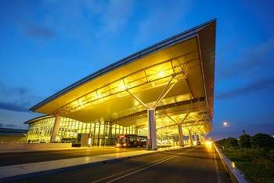 Hanoi Noi Bai Airport

Chi Min City, Saigon, in the south with internal air flights to speed us to our destinations. Vietnam today has approximately 80 million people and there are about 60 million motor bikes. Our closest state in size would be about 80% of California with approximately 39 million people and approximately 14 million cars.

As we all know our first of anything is always special and the older we become, those wow moments seem to come farther and farther apart. So, with eyes wide open and our hearts and mind ready to explore a new world, we stepped off the plane with a smile and excitement, which overcame the unspoken fears of what in the world are we doing here?!!

Those first thoughts were: we are in the land of a Communistic Government, and then we quickly just moved through customs, just like any other airport we have traveled through, our luggage where it was to be, we even found English signs all over and smiles on all the faces. There were no guns or soldiers or Communistic banners, just a bright new spotless airport no different than others, gleaming in stainless, obvious a point of pride there.
We found our driver with a huge “Goodrich” sign waving in the air - it was spelled correctly and we took that as a good sign all was going to be okay. The young driver was in a new Toyota, with Michael Jackson music blasting from the radio and after a few exchanges of words which I am sure was the limit of his English, we sat back and let the views sink in. The airport is in the countryside, with a brand new four-lane highway and an equally new and large bridge over the Rat River. It seemed so different from the city of Bangkok we had just left.

We passed modern cars, but most were motor bikes, the mode of transportation for most Vietnamese. Those bikes were always a wonder and the longer we were there the more impressed we became with them, for they not only held people, but it was impressive to see entire families, yes, Mom Pop and two or three children and often a baby tied in place somewhere. In addition, boxes, cages, or whatever were often piled up in amazing heights. Yet, they moved with fluid movements like a gentle breeze blowing by, except when the toots started from their horns, far from gentle.

We watched men and women working in the fields along the highway, no tractors or modern equipment, simply men and women, wearing, of all things those conical hats. I had seen them in old pictures and here they were in daily use there. Bikes were lying beside the fields, we saw people hoeing and raking, the mom-and-pop kind of garden work we see here but these I think were actually huge farms. The air was far from clear, as we soon learned Hanoi has dangerous levels of pollution and bad air quality many days, a day of sunshine is quite a treat.

Next week: Buildings and bikes …. Lots and lots of bikes!

Dog Walker Needed!

Miriam Devery reports that her daughter Gail, who has suffered a stroke, is due to be discharged to Miriam's home this next coming week. Gail is a teacher in the Red Wing School district and this was a completely unexpected event. She is making progress, and the physical therapist is already having her walk without a walker.
Miriam requests that if anyone would like to do a good deed, it would be helpful for you to come to Miriam’s house and walk Gail's dog Daisy, a sweet Boston terrier who needs a lot of exercise. Anytime -- day or evening. Just call Miriam at 763.473.3941. She lives in Plymouth at 17110 11th Avenue North.

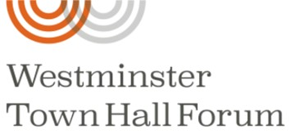

The second forum in the Westminster Town Hall “On Democracy” series will be held at 12:00 noon on Monday, October 4.

Dr. Wendy Hui Kyong Chun leads the Digital Democracies Institute at Simon Fraser University in Canada. Her upcoming book, Discriminating Data, delves into how social media platforms are designed to make us hate one another across political, racial, and class lines. She will speak at the Forum on how the internet and algorithms have undermined democracy and how they could be used in the pursuit of racial and social justice.

The forum will be broadcast live here: https://westminsterforum.org/forum/democracys-digital-dilemma/.

This Week
Wednesday, September 29
7:00 pm – Liberia Project meeting, on Zoom.

Thursday, September 30
10:30 am – Bible Study, on Zoom. Heidi will be leading discussion on Ephesians 2: 14-22.

Sunday, October 3: World communion Sunday. Special Offering will be dedicated both at the 9am Zoom service and at the 10:30 in person worship service.
9:00 am – Zoom Worship Service
10:30 am – In-Person Worship Service (masked and socially distanced). 10:30am in person worship in the sanctuary: Elizabeth Greene is the liturgist. Pastor Heidi will preach “Breaking Down Dividing Walls of Hostility.” Communion will be celebrated near the end of the service, as we all walk out the front door and are served juice in little Dixie cups and pieces of bread. Val Eng will be our musician.

Next Week

Tuesday, October 5
10:30 am – Morning conversation and prayer, on Zoom. Everyone welcome!!

Wednesday, October 6
7:00 pm – Liberia Project meeting, on Zoom.

Thursday, October 7
10:30 am – Bible Study, on Zoom. Heidi will be leading discussions on the texts Amos 5:6-7 and 10:15; Mark 10:17-31.

Sunday, October 10 – Worship
9:00 am – Worship service via Zoom
10:30 am – In-Person Worship. Michelle Gallick is liturgist

If You Have Information that needs to be in the weekly update such as meeting dates and times, special events or prayer requests, please get this information to our office manager Patrice by Wednesday morning. Please email or call peaceprezSLP@gmail.com or 952-545-2586.

Upcoming Birthdays

Patrice Meschke September 30
Mary Ann Christianson October 2
Sarah Gallick October 4
Dennis Hovdenes October 13
Robin Councilman October 14
Sue Tolchiner October 17
Elizabeth Greene October 18

Worship Resources

You can click on this link to join the Zoom meeting, for Sunday, Tuesday, Wednesday, and Thursday meetings:
https://zoom.us/j/5046768135
To dial in, call 312-626-6799 (long-distance).
The meeting ID is 504-676-8135.
For Facebook Live: https://www.facebook.com/PeacePresbyterian
To watch previous worship recordings on our YouTube channel, go to
www.youtube.com/channel/UCvOa5jl8xld1VtI105h6ZRA/.
They are also on our website at https://www.peaceprez.com/worship-recordings/.
We will continue posting Sunday bulletins ahead of the service on our website at https://www.peaceprez.com/news/publications/

