7

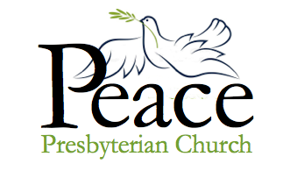

Midweek Update for the week of
November 7 – November 13, 2021
Published November 10, 2021

God of the Women!

On Sunday our scripture text will be from the Old Testament, from the very beginning of 1 Samuel 1. We will hear about Hannah, mother of Samuel, who suffered from infertility — and from a husband who criticized her harshly when she prayed to the Lord. He thought she was drunk, but she was just praying! As part of the service, we will be hearing (and humming along with) a hymn written by Carolyn Gillette Winfrey, sung to the tune of Be Thou My Vision:

God Of the Women

God of the women who answered your call,
Trusting your promises, giving their all,
Women like Sarah and Hannah and Ruth —
Give us their courage to live in your truth.

God of the women who walked Jesus' Way,
Giving their resources, learning to pray,
Mary, Joanna, Susanna, and more —
May we give freely as they did before.

God of the women long put to the test,
Left out of stories, forgotten, oppressed,
Quietly asking: "Who smiled at my birth?" —
In Jesus' dying you show us our worth.

God of the women who ran from the tomb,
Prayed with the others in that upper room,
Then felt your Spirit on Pentecost Day —
May we so gladly proclaim you today.

O God of Phoebe and ministers all,
May we be joyful in answering your call.
Give us the strength of your Spirit so near
That we may share in your ministry here.

From the Pastor

On Saturday at 4pm our Liberia Schools Project is having a Zoom meeting to which all are invited. Under the leadership of Julie North and Elizabeth Greene the Liberia Schools Project seeks to provide aid to public school students in Liberia.
Our first project is to work with Books for Africa, a non-profit organization based in Minnesota, to send books to children in Liberia. This will be our Advent mission project. You will be able to give a book to a Liberian child by donating money to Peace Church. I will be giving these books as a Christmas present to my mother and other family members. I invite you to plan to do this too.

This international mission work that has begun is a result of the fact that we now have members of our church (Joan Amara and Elizabeth Greene) who were born in Liberia and have family there. As a result, they are aware of the difficulties in their home country and have invited us to help.

Did you know that only about 60% of people in Liberia are literate? In some areas of the country primary and secondary education is free but in many places, children are required to pay a tuition fee to attend school. The country’s education sector is hampered by inadequate schools and supplies, as well as a lack of qualified teachers. Our own Dana Councilman, who served as a teacher in Liberia while a Peace Corps volunteer, has explained that the situation of education in Liberia is difficult indeed.
Liberia was founded in the early 1800s as a project of the American Colonization Society which believed that freed slaves would be better off in Africa than in the United Sates. Between the 1820s and the American Civil War, more than 15,000 black people from the United States — both those born free and those who had formerly been enslaved — moved to Liberia and bought their culture with them, including a constitution based on the US Constitution. Liberia declared independence in 1847, the first democratic republic on the continent of Africa.
We are grateful to Elizabeth Greene for her passion to help children in Liberia. As a church we have decided to get involved. We invite you to join us on Saturday at 4pm on Zoom.
Faithfully yours, Pastor Heidi

Peace Church collects donations each November to buy turkeys for STEP. If you want to help STEP clients have a Happy Thanksgiving, please consider donating. Make sure you designate your gift for TURKEYS and we will make sure STEP receives it.

The Peace offering allows our congregation to keep 25% of the donations to be used in our community. This year we gave $350.00 to the Lift Garage. With this gift
they are able to:

- Reduce each car repair bill for low-income Minnesotans by an average of 67%.
- Provide free vehicle inspection for those purchasing a different car
- Provide free Care Classes once a month
We all know how important a well-running car so we can work, transport children, get
groceries. The Lift Garage is changing the world one car repair at a time.

Pat Wilson

Upcoming Zoom and
In-Person Meetings

This Week

Wednesday, November 10
7:00 pm – Get-Together, via Zoom.

Thursday, November 11
10:30 am – Bible Study, on Zoom. Text is 1 Samuel 1: 4-20.

Saturday, November 13
4:00 pm – Liberia Schools group, via Zoom.

Sunday, November 14 – Worship Service
9:00 am – Worship service via Zoom
10:30 am – In-Person Worship. Liturgist, Bob Unze.

Next Week

Tuesday, November 16
10:30 am – Morning conversation and prayer, on Zoom. Everyone welcome!!

Wednesday, November 17
7:00 pm – Get-Together, via Zoom.

Thursday, November 18
10:30 am – Bible Study, on Zoom

Sunday, November 21 – Worship Service / Pledge Sunday
9:00 am – Worship service via Zoom
10:30 am – In-Person Worship. Liturgist, Teresa Emde.

If You Have Information that needs to be in the weekly update such as meeting dates and times, special events or prayer requests, please get this information to our office manager Patrice by Wednesday morning. Please email or call peaceprezSLP@gmail.com or 952-545-2586.

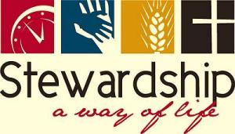

Peace Church is a giving church. It is in our DNA. When Peace Church was founded the idea of giving to others was very important.

Giving is not necessarily a gift of Financial Support only but giving is also the ability to give Time as a gift to others. This Time can not only be to others but to the church. Peace Church has received a gift of talented Individuals that have given many hours of time to support the church. This talent of the congregation was very important in the beginning of the church and has been seen in the years including now. We currently have many volunteers including the Elders, Deacons, Ushers, Greeters, and volunteers to other mission organizations.

Peace Church has also given financial support to other various mission organizations. There is also a mission of the support of Peace Church. It is important to give to others but to do that effectively there must be a strong financial organization to work from.

Remember, November 21 is Pledge Sunday.

The Stewardship Ministry

A Virtual Tour of Vietnam

This week, Tom and Eunice travel from Halong Bay to Hue, the former capital of Vietnam.

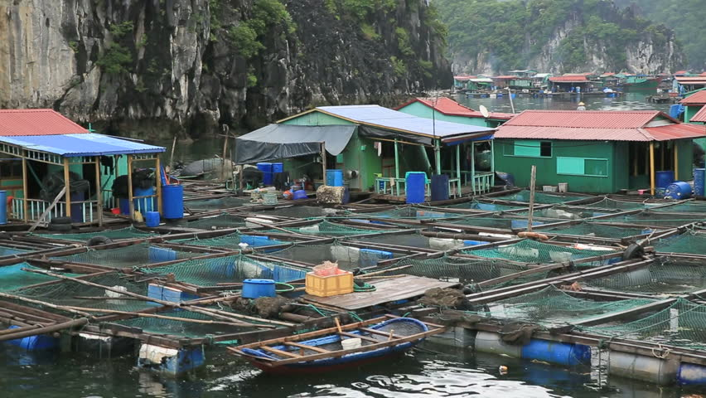

In Halong Bay you find a collection of barrels bound together with a roof on top, and you are in the midst of a fishing village. Children live life on the water, jumping with ease from boat to boat, some never touching land until they have finished early childhood education and then move on to schools.
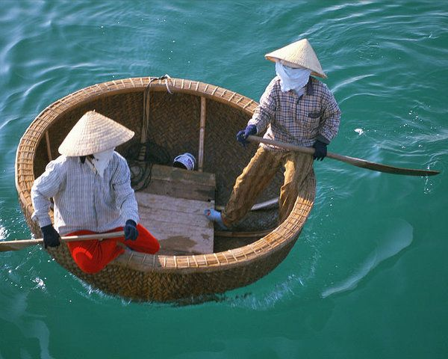
The fishermen navigate in tiny lacquered and woven wood “coracles” which are nothing more than floating baskets, without rudders. They look like a floating oversized tub, and the fishermen are fearless, their little boats bouncing up and down in the waves as they simply go about their business of fishing. I was so amazed to watch as they bobbed up and down, looking like a boat a child would build to play in, and yet here it was used by adults to do their daily task, catching fish.

It was almost surreal at night to sit on the deck and watch the moon shine down, with dots of light here and there from other Junks also spending the night in the bay. It was so quiet, I noticed that those of us talking and enjoying our wine and conversations all unanimously lowered our voices and talked softly into the night. It was almost a sacred moment in time where all knew this was a gift to be taken in, as we gazed to the heavens and the memory was etched in our minds.

We then drove back to Hanoi airport to fly to Hu and then on to Hoi An.

Hue, located on the central coast of Vietnam, was the former capital during the Nguyen Dynasty, considered the golden age of Vietnam. For many years Hue has been considered the cultural, religious, and educational center of Vietnam.

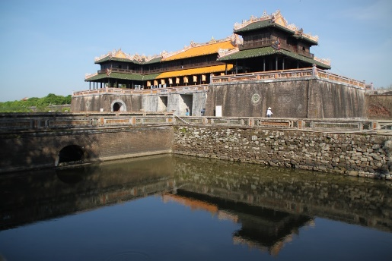
We toured the old city, which is a moated, walled citadel surrounded by eleven stone gates. In the citadel we went into the Imperial Enclosure and saw the inner Forbidden Purple City, a private area reserved for the Emperor.

What stuck out in my mind was the confusion we all had trying to find our shoes, which of course are left outside, but the door in and the door out was different! If we had been the only visitors, it would have been no problem, but finding our shoes among the many there, seemed a bit hopeless and in the long run we had a good laugh.

One interesting point was our lunch in Hue in a monastery occupied by women monks, several of which we had an opportunity to chat with. Often a poor family takes their child there to be educated and fed, however it is mostly males. These young women were mostly already educated, well read, and we found it a bit difficult to understand why they would choose such a life. I guess it was their faith, just as women in the West chose to become nuns.

Next week: Hoi An and China Beach.

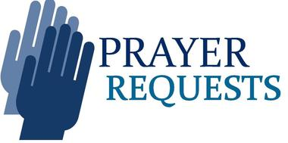

After giving thanks for a gorgeous day on Tuesday, the prayer group prayed for an end to the COVID-19 pandemic, and for people who have been so negatively affected by it.

Pray for the entire medical system which is overwhelmed, causing unnecessary suffering and death even for people who are not sick from Covid-19. While we give thanks for booster shots, we also pray for a just distribution of the vaccine to poorer countries.

The whole group asked for prayer for our country that is so divided.

Lynne Kubista asked for prayers for their "bonus" daughter (informally adopted) who lives in England and is in danger of losing her home.

Frank Vardeman offers prayers of gratitude that the Build Back Better legislation includes funds to make all public transportation handicap accessible.

Mary Ann Christenson gives thanks for great grandson Harrison Alexander Beach, born January 15, 2021, who is named after her (Alexander is Mary Ann's maiden name).

Jake Hamilton gives thanks for golf, football, bowling and. being able to be with his girlfriend Amanda.

Eunice Goodrich gives thanks for our church, which she described in her Christmas letter (already written!) as "small but a mighty force working for the common good of all."

We pray for people who are without permanent homes and for those who have homes but are going to have a difficult winter as fuel prices increase. Help get their applications in to get energy assistance from the state.

John Maier gives thanks for a story in the Star Tribune about a woman who was homeless in Rochester as a teeanger but is now in graduate study at Oxford University in England seeking to find ways to inform world leaders about hunger and food insecurity causes war and violence.

Rosemary Hall asks for prayers for Kent’s family and especially for her brother- in -law Quentin Hall who was hospitalized last Friday evening with chest pain. He is doing better and has been discharged.

Prayers of gratitude from Rosemary for the good weather which allowed us to dig all the dahlias and get them stored for the winter.

Upcoming Birthdays

Heidi Vardeman November 23
Jim Moffett November 28

Worship Resources
You can click on this link to join the Zoom meeting, for Sunday, Tuesday, Wednesday, and Thursday meetings:
https://zoom.us/j/5046768135
To dial in, call 312-626-6799 (long-distance).
The meeting ID is 504-676-8135.
For Facebook Live: https://www.facebook.com/PeacePresbyterian
To watch previous worship recordings on our YouTube channel, go to
www.youtube.com/channel/UCvOa5jl8xld1VtI105h6ZRA/.
They are also on our website at https://www.peaceprez.com/worship-recordings/.
We will continue posting Sunday bulletins ahead of the service on our website at https://www.peaceprez.com/news/publications/

