Sunday, July 17, 2022

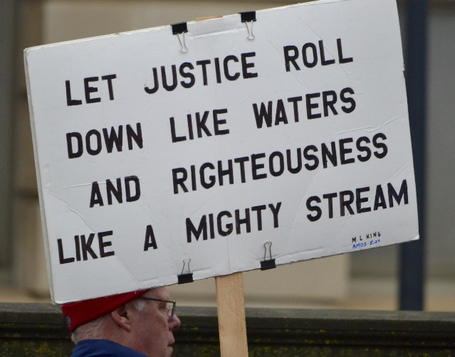

9:00 Zoom Edition
https://us02web.zoom.us/j/5046768135
Meeting ID: 504 676 8135
Or dial by your location
+1 312 626 6799 US (Chicago)
AND
10:30 am In-Person Worship
Streaming on Facebook at:
https://www.facebook.com/PeacePresbyterian

Order of Worship

Prelude Patrice Meschke

Welcome Pastor Heidi Vardeman

Gathering Song I Have Decided to Follow Jesus
I have decided to follow Jesus;
I have decided to follow Jesus;
I have decided to follow Jesus;
No turning back, no turning back.

Let justice roll down like waters
Let justice roll down like waters

Let justice roll down like waters
And righteousness like a mighty stream.

Call to Worship Liturgist
Let us sing to the Lord.
We tell of God’s glorious power and rejoice in God’s ever-present love.
Through baptism, each of us has been adopted into God’s family.
We are the body of Christ in the world, held responsible for the carrying out of God’s will.
Let us worship God.

Hymn #477, vs. 1,3,4 Ye Servants of God,
Your Master Proclaim
You servants of God, your Master proclaim,
and publish abroad God’s wonderful name;
The name all-victorious of Jesus extol;
God’s kingdom is glorious and rules over all.

"Salvation to God, who sits on the throne!"
Let all cry aloud, and honor the Son;
The praises of Jesus, the angels proclaim,
Fall down on their faces and worship the Lamb.

Then let us adore and give Him his right:
All glory and power, all wisdom and might,
All honor and blessing with angels above
And thanks never ceasing for infinite love.

Confession of Sin
Let us together admit our sin to God, each other and ourselves. Let us pray:
We admit, gracious God, that we have strayed from the pathway of faith. We have done those things that we ought not to have done and have not done those things that we ought to have done. Have mercy on us. (silent prayer)

Sung Response (unison)
You are the Lord, the author of mercy
You are the Christ, the pattern of mercy
You are the Lord, who holds us in Mercy.

Declaration of Forgiveness
… Believe the good news of the gospel:
In Jesus Christ we are forgiven. Alleluia and amen!

Song of Rejoicing The First Song of Isaiah
Surely, it is God who saves me;
I will trust in God and not be afraid.
For the Lord is my stronghold and my sure defense,
and God will be my Savior.

Surely, it is God who saves us;
We will trust in God and not be afraid.
For the Lord is our stronghold and our sure defense,
and God will be our Savior.

Passing the Peace
… The peace of Christ be with you.
And also with you.

Concerns of The Church

Scripture Reading Amos 8: 1-12
This is what the Lord God showed me—a basket of summer fruit. He said, ‘Amos, what do you see?’ And I said, ‘A basket of summer fruit.’ Then the Lord said to me,
‘The end has come upon my people Israel;
I will never again pass them by.
The songs of the temple shall become wailings on that day,’
says the Lord God;
‘the dead bodies shall be many,
cast out in every place. Be silent!’

Hear this, you that trample on the needy,
and bring to ruin the poor of the land,
saying, ‘When will the new moon be over
so that we may sell grain;
and the sabbath,
so that we may offer wheat for sale?
We will make the ephah small and the shekel great,
and practice deceit with false balances,
buying the poor for silver
and the needy for a pair of sandals,
and selling the sweepings of the wheat.’

The Lord has sworn by the pride of Jacob:
Surely I will never forget any of their deeds.
Shall not the land tremble on this account,
and everyone mourn who lives in it,
and all of it rise like the Nile,
and be tossed about and sink again, like the Nile of Egypt?

On that day, says the Lord God,
I will make the sun go down at noon,
and darken the earth in broad daylight.
I will turn your feasts into mourning,
and all your songs into lamentation;
I will bring sackcloth on all loins,
and baldness on every head;
I will make it like the mourning for an only son,
and the end of it like a bitter day.
The time is surely coming, says the Lord God,
when I will send a famine on the land;
not a famine of bread, or a thirst for water,
but of hearing the words of the Lord.
They shall wander from sea to sea,
and from north to east;
they shall run to and fro, seeking the word of the Lord,
but they shall not find it.

Sermon A Basket of Summer Fruit

Hymn #2174 What Does the Lord
Require of Us?
What does the Lord require of us?
What does the Lord require of us?
What does the Lord require of us?
What does the Lord require of us?

Justice, kindness, walk humbly with our God.
Justice, kindness, walk humbly with our God.

To seek justice, and love kindness, and walk humbly with our God
To seek justice, and love kindness, and walk humbly with our God

Sharing of Our Joys and Concerns

Prayers of the People

The Lord’s Prayer
Our Father in heaven, hallowed be your name, your kingdom come, your will be done, on earth it is in heaven. Give us today our daily bread. Forgive us our sins as we forgive those who sin against us. Save us from the time of trial and deliver us from evil. For the kingdom, the power, and the glory are yours now and forever. Amen.

Offertory

Doxology #591

Prayer of Dedication

Hymn #2172, vs. 1-2 We are Called
Come, live in the light
Shine with the joy and the love of the Lord
We are called to be light for the kingdom
To live in the freedom of the city of God

We are called to act with justice
We are called to love tenderly
We are called to serve one another
To walk humbly with God

Come, open your heart
Show your mercy to all those in fear
We are called to be hope for the hopeless
So all hatred and blindness will be no more

We are called to act with justice
We are called to love tenderly
We are called to serve one another
To walk humbly with God
Benediction

Closing Song We are Called (refrain)
We are called to act with justice,
We are called to love tenderly,
We are called to serve one another,
To walk humbly with God

Postlude

