“And 7

Midweek Update for the week of
August 28 – September 3, 2022
Published August 31, 2022

SPECIAL HOT DOG SUPPER TONIGHT!!
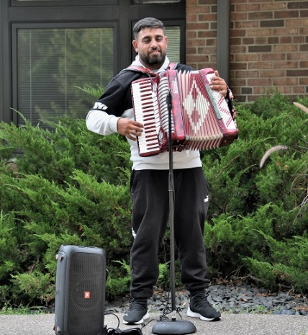
It’s our last Hot Dog dinner for the summer tonight - Wednesday, August 31. As Robin Councilman said this past Sunday, this has been a learning experience over these past two months, but we have had the opportunity to spend time with friends and neighbors and our crowds have steadily grown over the summer.

Val Eng of the Fellowship Committee notes: “We have greatly enjoyed the accordion playing of Mario, the musician JoAnn met in St. Louis Park, and his young daughter as well. Mario has played for two of our suppers, but he and his daughter will need to leave for California very soon to hopefully resolve an immigration issue. He is Serbian and has been here for approximately six months.

Mario will play for us tonight, perhaps for the last time. This past week JoAnn has supplied him and his daughter with some clothing.”

The 3 B FAQ (Frequently Asked Questions) … Answered!

What is it? A program developed to enhance the lives of seniors, through walking, exercise, devotions, humor, fun facts, brain teasers and social connection!

When is it? Tuesdays 2-3 pm and Thursdays 10:30-11:30 am, September 20 through Nov. 10

Where is it? In the fellowship hall of Peace Presbyterian Church.

What to wear? Comfortable clothing, well-fitting non-skid shoes.

What to bring? Water if desired, doctor’s information and emergency contact information for first session forms.

Is it easy/hard? Jen will provide a wide range of options for completing each exercise, so they can benefit people of all abilities: the exercises can be as easy as wiggling toes while sitting in a chair, or as hard as performing squats while balancing on one leg! Jen believes is best to start small and avoid straining.

Exercise examples? We will start out with walking, then exercising while sitting in a chair: we will work on sitting posture, ankle movements, leg kicks, arm movements, hand and toe movements. Exercises can be made easier by making the movements smaller, reducing resistance, or adding support. Exercises can be made harder by adding resistance band or doing exercises while standing instead of sitting (with support of a chair available for balance).

Why exercise? Even a small amount of exercise at a slow pace can help! Exercise can make it easier to do our day-to-day activities, move stiff/painful joints, and get out of chairs. Exercise helps reduce the risk of falls and injuries and helps us maintain independent lifestyles. Exercise also sharpens our minds, can improve our mood, and can help protect against dementia/ Alzheimer’s disease.

Is it safe? A medical doctor will regularly advise us regarding COVID protocols. We will use a large, open meeting space with ample space between us. Jen strongly encourages everyone to exercise at a safe pace. Jen has many years of experience in home care physical therapy and can respond if there is a medical concern. There will be chairs and walls available for support if you choose to exercise in a standing position.

Equipment? Using equipment is optional: we will have light resistance latex exercise bands available to gently strengthen our arms, and squishy foam balls to strengthen our hands. Jen will have other miscellaneous items available to enhance/ease our experience. Please let Jen know if you have a latex allergy.

Will we have fun? Yes!!!

Is it ok to go slow? Yes!!!

Can I do it? Yes!!! Jen can help ensure anyone can participate safely.

Will it be online? We will start out by posting the video of the session the next day on Facebook/YouTube. Eventually live streaming may be available.

The next Mission Committee meeting will be held Thursday, September 2 at 1:30 pm on Zoom.

Upcoming Zoom and
In-Person Meetings
Use these links to access online meetings:
https://us02web.zoom.us/j/5046768135
https://www.facebook.com/PeacePresbyterian

This Week

Wednesday, August 31
6 – 7 pm – FINAL Hot Dog Dinner for the summer!

Thursday, September 1
11:00 am – Zoom Meeting.

Sunday, September 4 – Worship Service
Jen Bach preaching
9:00 am – Zoom Service
10:30 am – Worship in the Sanctuary

Next Week

Monday, September 5
Office closed for Labor Day holiday

Tuesday and Thursday Zoom meeting information will be announced soon.

Saturday, September 10
10:00 – Book Club meeting at church

Sunday, September 11 – Worship Service
Pastor Heidi preaching
9:00 am – Zoom Service
10:30 am – Worship in the Sanctuary

Upcoming

Tuesday, September 20
2:00 pm – The 3B Program starts
7:00 pm – Session meeting, via Zoom.

If You Have Information that needs to be in the weekly update such as meeting dates and times, special events or prayer requests, please get this information to our office manager Patrice by Wednesday morning. Please email or call peaceprezSLP@gmail.com or 952-545-2586.

Michele Gallick is hosting “The Final Fiesta” before Sarah (Gallick) and Chad say their I Do’s. Walking tacos will be served, and all are cordially invited!

Date: Saturday, September 3, 2022
Time: 2:00 pm until ??????
Place: 6019 Cedar Lake Road, SLP

Eunice Goodrich shares with us her story of the lovely bluff country in southeastern Minnesota, which she just wrote for her writing group at Plymouth community Ed. Thanks, Eunice!

By a miracle of nature southeastern Minnesota’s last ancient glaciers skipped that part of the world and today we all are the benefactors, for it left behind miles of bluffs that surround the Mississippi River Valley and my hometown Dakota, that resides in this gorgeous spot on our Planet Earth.

Nestled beside the river with the bluffs of Minnesota on one side and the bluffs of Wisconsin across the river, it is a source of serenity. Known not only for its beauty, but also for generations the bluffs have allowed migrating birds to stop and rest and gather energy to continue their migration up the river.

As I grew older and more mature the quiet grew sometimes too quiet and the daily routine sometimes too dull; however, my appreciation of the bluffs grew as they became some of the best entertainment beauty and amusement around.

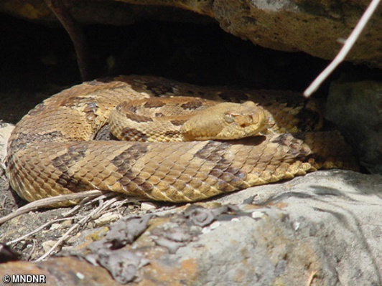
Have you ever climbed a bluff? For quite a few years my family and our friends the Talgs had our annual Winnie roast climb; always in the fall after the first killing frost when the rattlesnakes that sunbathed on the exposed rocks were gone. Yes, there were rattlesnakes in Minnesota; however, to be truthful no one in the village ever remembered anyone getting bitten.

My mother became friends with Bev through her Business and Professional Women’s Club in La Crosse, WI. A bond was formed when they discovered they each had two children. The eldest a girl, and the youngest a boy, all around the same age group and the husbands enjoyed sharing their humor over the evening cocktail hour.

It must have been an interesting sight; all 8 of us gathered in our front yard with my father in command with his whistle around his neck and his tiny army surplus backpack, held in place by small straps that dug into his huge shoulders.

Picture the fathers, a mix of Pillsbury Dough Boy and the Michelin Man all mixed tougher with a dash of smile that could make the world all right. The mothers were small, petite, well-rounded women, business and professional women who knew how to give directions to anyone they knew needed it, who had replaced their suits and hose for jeans, sweatshirts and bandanas wrapped around their heads.

Allyn and I were deep in our ugly duckling role in life, and it would take a few years for those swans to emerge; and as far as the boys - Billy, (does the name Ichabod Crane bring any images for you?) always loved to brag to anyone within earshot, “I am the ugliest boy in the tri-state region and here is my twin brother Richard.”

My father would give the marching orders and across the street we crossed over a barb wire fence with the help of a two-sided ladder. Of course, the boys always decided to go army crawl under, usually one or both getting caught and needed rescue from one of the fathers. Clear sailing for a bit though a cow pasture, when one heard my father’s second command, watch your step, however always a few seconds too late before someone had mushed into a gooey cow pie. Down a gentle slope in the pasture lay a small stream babbling away, Jump came the third command and usually everyone, but Allyn and I made it safely, making my father’s fourth command, Girls this is not the Grand Canyon, Jump which we usually did into the water.

Next week: Getting to the top

Happy Birthday!

Jen Bach September 1
Bonnie Okronglis September 2
Donna Taschner September 7
Ron Taschner September 20

Worship Resources

Peace Presbyterian Church always uses the same Zoom address for all meetings and worship.
You can click on this link to join the Zoom meeting, for Sunday, Tuesday, Wednesday, and Thursday meetings:
https://zoom.us/j/5046768135
To dial in, call 312-626-6799 (long-distance).
The meeting ID is 504-676-8135.
For Facebook Live: https://www.facebook.com/PeacePresbyterian
To watch previous worship recordings on our YouTube channel, go to
www.youtube.com/channel/UCvOa5jl8xld1VtI105h6ZRA/.
They are also on our website at https://www.peaceprez.com/worship-recordings/.
We will continue posting Sunday bulletins ahead of the service on our website at https://www.peaceprez.com/news/publications/

