Sunday, September 4, 2022

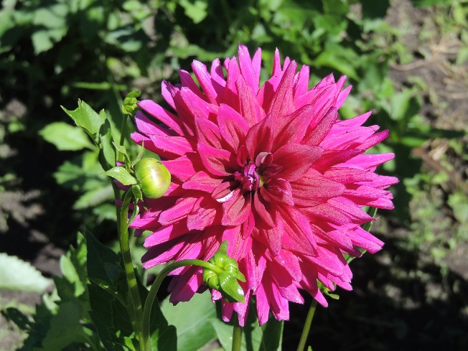

9:00 Zoom Edition
https://us02web.zoom.us/j/5046768135
Meeting ID: 504 676 8135
Or dial by your location
+1 312 626 6799 US (Chicago)
AND
10:30 am In-Person Worship
Streaming on Facebook at:
https://www.facebook.com/PeacePresbyterian

Order of Worship

Prelude Val Eng

Welcome Terry Kubista

Gathering Song Bless His Holy Name

Bless the Lord, O my soul, and all that is within me, bless his holy name!
Bless the Lord, O my soul, and all that is within me, bless his holy name!
He has done great things, he has done great things,
He has done great things, bless his holy name!
Bless the Lord, O my soul, and all that is within me, bless his holy name!
Call to Worship
Creating God, we gather in your name to worship you.
We give thanks for the small spark of God within us. Kindle that small spark into a flame of love and service.
Sustaining God, we gather in your name to worship you.
We celebrate the loving presence of God in our life. May God’s loving presence be a strong influence in our life.
Nurturing God, we gather in your name to worship you. We rejoice that God teaches us about love and forgiveness.
As we grow in faith, trust and love for God, may our worship, witness and service bring honor to God’s Holy Name. Amen

Hymn #335, vs. 1-3 Though I May Speak

Though I may speak with bravest fire, and have the gift to all inspire,
And have not love, my words are vain, as sounding brass and hopeless gain.

Though I may give all I possess, and striving so my love profess,
But not be given by love within, the profit soon turns strangely thin.

Come, Spirit, come, our hearts control, our spirits long to be made whole
Let inward love guide every deed, but this we worship and are freed.

Confession of Sin
Forgive us, gracious God, for believing too much in the values of the world and too little in You. You love us intensely but too often we do not love ourselves – or our neighbor. Help us to love in the profound way that you love us. Forgive us for being afraid of the judgments of other human beings. Pardon us for giving in to the powerful when they are in any way contrary to your will. Forgive us for not listening to you. Hear our prayer as we confess our sins silently to ourselves – and to you. (Pray silently.) Help us, God.
In your great mercy, God, welcome us back into your arms and connect us to your great vine of life. Restore in us the joy of your salvation and sustain us with your bountiful spirit. Amen.

Sung Response (unison)
You are the Lord, the author of mercy
You are the Christ, the pattern of mercy
You are the Lord, who holds us in Mercy.

Declaration of Forgiveness
… Believe the good news of the gospel:
In Jesus Christ we are forgiven. Alleluia and amen!

Song of Rejoicing The First Song of Isaiah
Surely, it is God who saves me;
I will trust in God and not be afraid.
For the Lord is my stronghold and
my sure defense,
and God will be my Savior.

Surely, it is God who saves us;
We will trust in God and not be afraid.
For the Lord is our stronghold and
our sure defense,
and God will be our Savior.

Passing the Peace
… The peace of Christ be with you.
And also with you.

Concerns of The Church

Scripture Reading Luke 10: 38-42

Now as they went on their way, he entered a certain village, where a woman named Martha welcomed him into her home. She had a sister named Mary, who sat at the Lord’s feet and listened to what he was saying. But Martha was distracted by her many tasks; so she came to him and asked, ‘Lord, do you not care that my sister has left me to do all the work by myself? Tell her then to help me.’ But the Lord answered her, ‘Martha, Martha, you are worried and distracted by many things; there is need of only one thing. Mary has chosen the better part, which will not be taken away from her.’

Sermon A Work of Value (Jen Bach)

Hymn #452 (GTG) Open the Eyes of My Heart

Open the eyes of my heart, Lord
Open the eyes of my heart
I want to see You, I want to see You

Open the eyes of my heart, Lord
Open the eyes of my heart
I want to see You, I want to see You

To see You high and lifted up
Shining in the light of Your glory
Pour out Your power and love
As we sing holy, holy, holy

Holy, holy, holy
Holy, holy, holy
Holy, holy, holy
I want to see you

Sharing of Our Joys and Concerns

Prayers of the People

The Lord’s Prayer
Our Father in heaven, hallowed be your name, your kingdom come, your will be done, on earth it is in heaven. Give us today our daily bread. Forgive us our sins as we forgive those who sin against us. Save us from the time of trial and deliver us from evil. For the kingdom, the power, and the glory are yours now and forever. Amen.

Offertory

Doxology #591

Prayer of Dedication

Hymn #369 I’m Gonna Live so God Can Use Me

I'm gonna live so God can use me anywhere, Lord, anytime!
I'm gonna live so God can use me anywhere, Lord, anytime!

I'm gonna work so God can use me anywhere, Lord, anytime!
I'm gonna work so God can use me anywhere, Lord, anytime!

I'm gonna pray so God can use me anywhere, Lord, anytime!
I'm gonna pray so God can use me anywhere, Lord, anytime!

I'm gonna sing so God can use me anywhere, Lord, anytime!
I'm gonna sing so God can use me anywhere, Lord, anytime!

Benediction

Closing Song Go Now in Peace

Go now in peace. Never be afraid.
God will go with you each hour of every day.
Go now in faith, steadfast, strong and true.
Know He will guide you in all you do.
Go now in love, and show you believe.
Reach out to others so all the world can see.
God will be there watching from above.
Go now in peace, in faith, and in love.

Postlude

