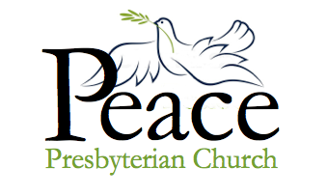
“And 7

Midweek Update for the week of
September 18 – September 24, 2022
Published September 23, 2022

Body, Brain, Belief launches with great success!
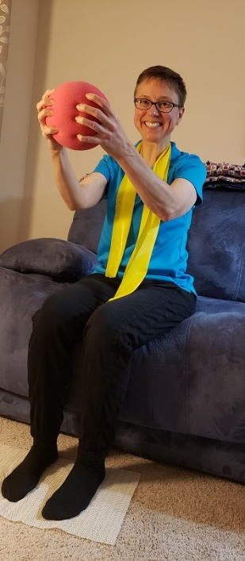
3B started on Tuesday, as 20 people gathered in the fellowship hall for gentle exercise (some people remaining seated the whole time), riddles, scripture, prayer and stories. The sessions are just under an hour, led by physical therapist / seminarian Jen Bach. Jen does a wonderful job modifying the exercises for those of us with knee, back or shoulder problems.

For 10 weeks, 3B will gather on Tuesdays at 2pm and Thursdays at 10:30am. All are welcome!! You don't have to come to all sessions. You don't even have to sign up officially. Just come and check it out!

From the Pastor:
The arrogance of the able-bodied

This week I came down with a nasty case of bronchitis. My grandson in NJ calls it "bronky-itis. I've been coughing and wheezing something fierce. I caught it as a result of the Vardeman family reunion in August. Frank's niece is a dentist, she gave it to her son, her son gave it to our Minnesota grandson Aaron, and Aaron gave it to me. I'm miserable.

I'm not accustomed to being sick. As one who comes from strong stock (note my mom's upcoming 100th birthday), I am reputed to be one of the healthiest persons around in regard to physical ailments. Mental health is something else; depression "lurks behind the door" (Gen 4:7), but my body is strong. I take physical health and strength for granted.

I call this the arrogance of the able-bodied. Those of us blessed with this kind of health can get impatient with those who are not. Without thinking, we might think them lazy malingerers. Before Frank's injury I used to chafe at accessibility requirements because, for example, spending lots of money for an elevator seemed a waste. If only a few people really need it, why bother?

You may have noticed that I have changed my tune. Frank's injury and succeeding infections saw to that. To be understanding and accommodating of people with health problems is not only the right thing to do, but it is a teaching of our faith. After all, who did Jesus hang out with? His association with the sick and the disabled really bugged the scribes and Pharisees. Probably drove his disciples nuts, too, as he was always stopping to heal and comfort. Maybe Jesus preferred to associate with those who weren't so full of themselves.

Monday's session meeting was supposed to be our first in-person meeting in more than two years, but I changed it to Zoom only so I wouldn't cough all over people.

As the week has progressed, I've been feeling a bit better, but on Thursday I lost my voice. In a memo to session members, I told them not to laugh . . . but I was laughing at myself. As a pastor, I love to talk. I love to talk from the pulpit, in meetings, on Zoom. I used to lecture in the classroom, did TV interviews and even used to have my own radio show. My PhD work was in speech, for heavens' sake.
Joni Mitchell sang, "Don't it always seem to go, that you don't know what you've got ‘til it's gone?" Thank you, God, for reminding me to be grateful for health and strong voice.

I expect to get my voice back before Sunday, but just in case, I've arranged for someone to read my sermon in case I don't. It never hurts to be prepared.

Your temporarily indisposed pastor,
Heidi
Weekly Fall Activities

MONDAY: Bible study, on Zoom, is now on Monday's at 2:00 pm.

TUESDAY: 3B meets at 2pm for one hour.

WEDNESDAY: Check-in / Prayer group meets on zoom at 10:30 a.m.

There will be a church dinner on Wednesday, October 5. Details about other Wednesday evening programs are still being developed.

THURSDAY: 3B will meet at 10:30am for one hour (the Bible study which used to meet on Thursday mornings is now be held on Mondays)

FRIDAY: No activities scheduled.

Upcoming Zoom and
In-Person Meetings
Use these links to access online meetings:
https://us02web.zoom.us/j/5046768135
https://www.facebook.com/PeacePresbyterian

This Week

Wednesday, September 21
10:30 – Check-in / Prayer on Zoom.

Thursday, September 22
10:30 – 11:30 am - 3 B Program

Sunday, September 25 – Worship Service
9:00 am – Zoom Service
10:30 am – Worship in the Sanctuary

Next Week

Monday, September 26
2:00 – Bible Study meeting, on Zoom.

Tuesday, September 27
2:00 - 3:00 pm - 3 B Program

Wednesday, September 28
10:30 – Check-in / Prayer on Zoom.

Thursday, September 29
10:30 – 11:30 am - 3 B Program

Sunday, October 2 – Worship Service
9:00 am – Zoom Service
10:30 am – Worship in the Sanctuary

If You Have Information that needs to be in the weekly update such as meeting dates and times, special events or prayer requests, please get this information to our office manager Patrice by Wednesday morning. Please email or call peaceprezSLP@gmail.com or 952-545-2586.

Special Music this Sunday

Ron Abrahamson will be providing special music this upcoming Sunday. Ron is a member of our Pop-Up Choir, and we thank him in advance for sharing his song with us!

When: Friday, October 21 5:00 pm to Sunday, October 23 at Noon. Carpooling is encouraged.

Where: YMCA of the St. Croix (Hudson, WI) -beautiful facilities, good food

What to bring: Yourself, clothes, toiletries, towel, bedding, walking shoes (there is an option to drive to the dining hall), fun activity or snack to share.

Why: Fun! If you have been to one of our retreats at the YMCA St. Croix, you know that it is a lovely place. It is a chance for us to relax and fellowship together.
Suggested cost: Weekend: $50 or Saturday $25 (First time retreat attendees are always free.) Please note we do not want cost to be a barrier for anyone. We would prefer you join us regardless of what you can or can’t pay.

Theme: Jeremiah 29:7 “But seek the welfare of the city where I have sent you into exile, and pray to the Lord on its behalf, for in its welfare you will find your welfare”

We’ll be discussing together ways to move Peace Church forward. We are going to talk about the skills we need to develop to talk to people we don't know - now that we have opened back up - and are beginning to think about welcoming new members into our church.

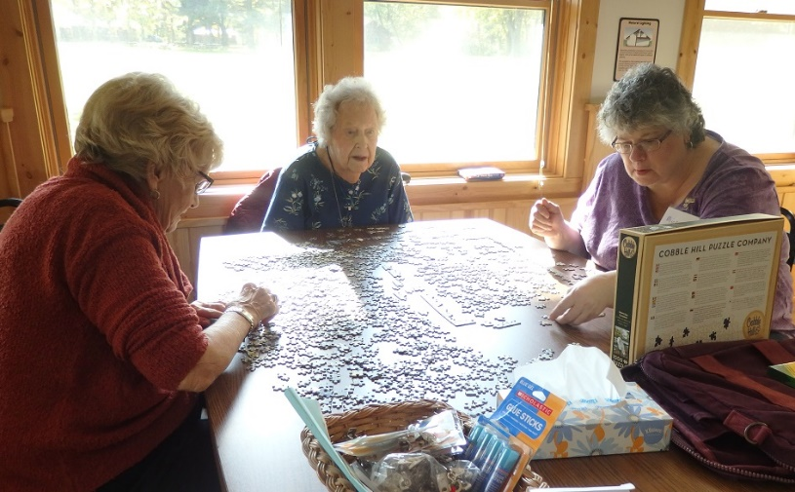

So, what is our next step? How do we now reach out to those in our community? How do we help neighbors become members? We will explore these questions as the focus of our retreat.

Questions: Ask Robin Councilman, Val Eng, or Pastor Heidi.

This week, we finish our series on the Doris Black Seminarian endowment gift. Thank you again, Eunice!
As Doris aged it became difficult for her to fly to family gatherings and the annual summer get-together on her own and she always found a nice or nephew willing to go along. In one session Doris asked me out of the blue, would you like to fly to the gathering with me this year? It shocked me and I did not take it seriously so just avoided the situation. However, she did not forget I had not given an answer and gave me a second change.

Sadly, I had to decline, I had two school-age children, I worked full time at a demanding job and could not imagine how in the world I could break away for such an adventure. I guess we all look back and think why didn’t I try harder, etc. It would have been much easier to write this article about her if I had only had the time to really get to know what a lovely woman she was!!

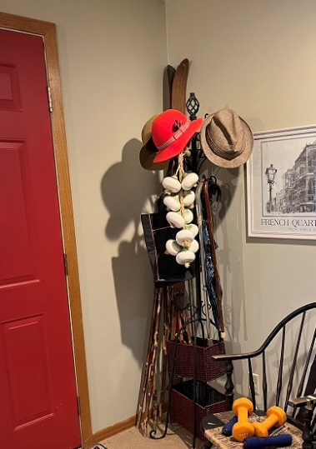
I did attend her funeral and her family had her hat collection all laid out for anyone in church who wanted a memento to take, I did not turn down this offer and now am the proud owner of an original Doris Black, a bright orange cloche, with a feather tucked onto the band. It has hung in our family room on a rack in the corner all these years and when I knew I should write a story about this lovely lady I found I had also tucked her obituary into the band.

For weeks I LABORED, how can I write about Doris when memory is dim and the years have slipped by. One day it hit me, yes this is it, that quiet faith deep in her core, her love of young people , and her devotion to Peace Church, her love of life, the love of her life Duncan who came from a strong bond of church from Scotland, it would only seem logical she would choose to give such a gift to future young people who wanted to dedicated their lives to the ministry in the Presbyterian Church.

We have been blessed by this legacy left by Doris. The first recipient of the endowment was Barbara West, and it continues to this day with Jen Bach, Benjamín Masters, Katrina Bergman and James Cochrane, the legacy does not end, there is always in the future a young seminarian that will benefit from this quiet gentle lady Doris Black.

You are cordially invited …

… to Jinny Hilf's 100th birthday party at the church.

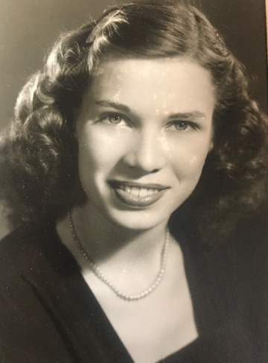
The celebration will take place at Peace Prez on Saturday, November 5, 4-6 pm in the lower level. It will be a faux cocktail party to celebrate Jinny and to raise funds for Planned Parenthood.

Jinny loves a party! There will be ginger ale, maraschino cherries, little paper parasols, lots of potato chips, dip, and big band music! Frank will "tend bar" assisted by his son-in-law Andy.

This will be a fundraiser for Planned Parenthood. Back in the day Jinny was the church lady volunteer who served as liaison between her church, Immanuel Presbyterian in Milwaukee, and Planned Parenthood of Wisconsin. A free clinic was held in the church education building every week.

What better to celebrate Jinny's 100th than to have a party remembering her volunteering at a clinic held in a church basement? It is no accident that the Presbyterian Church has long supported access to contraception and abortion services, as the first preliminary principle in our denomination's constitution is: "God alone is Lord of the conscience and hath set it free from the doctrines of men." (Ask Terry Kubista: this principal dates from the Westminster Confession of 1646.)

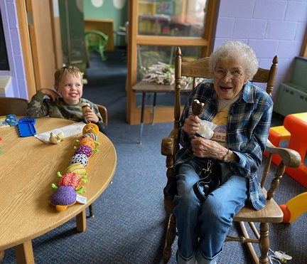
If you would be willing to help Pastor Heidi organize this event (cocktail dresses are optional, but you are invited to have fun in choosing what to wear!) please let Pastor Heidi know. We plan to have fun! Jinny's birthday is actually October 21, but she's happy to wait a couple of weeks to celebrate.

Please put it on your calendar! Volunteer to help if you'd like. Frank is going to "tend bar." All helpers are welcome!

We pray for .. . .

The Okronglis family. Scott's memorial service will be held at Peace at 11am on Saturday, Oct. 8, at 11am with a lunch to follow.

Susan Tolchiner and her son Joseph who continues with chemotherapy.

Anjel Starr who is finding his way on his own as he is now 18 years old.

Frank Vardeman who is hoping to be accepted by the Mayo Clinic for a second opinion about his current medical problems.

Donna Taschner got some discouraging results this week and awaits updates from her doctor. Please keep her in your prayers.

Happy Birthday!

Patrice Meschke September 30
Mary Ann Christenson October 2
Sarah Gallick October 4
Robin Councilman October 14
Susan Tolchiner October 17
Elizabeth Greene October 18

Worship Resources

Peace Presbyterian Church always uses the same Zoom address for all meetings and worship.
You can click on this link to join the Zoom meeting, for Sunday, Tuesday, Wednesday, and Thursday meetings:

https://zoom.us/j/5046768135
To dial in, call 312-626-6799 (long-distance).
The meeting ID is 504-676-8135.
For Facebook Live: https://www.facebook.com/PeacePresbyterian
To watch previous worship recordings on our YouTube channel, go to
www.youtube.com/channel/UCvOa5jl8xld1VtI105h6ZRA/.
They are also on our website at https://www.peaceprez.com/worship-recordings/.
We will continue posting Sunday bulletins ahead of the service on our website at https://www.peaceprez.com/news/publications/

